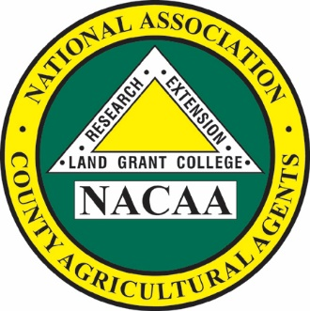

Scott Jensen

*President*

110th Annual Meeting

June 29 – July 2, 2025

Billings, Montana

*NACAA is an Equal Opportunity*

*Professional Association*

**National Association of County Agricultural Agents**

NACAA Headquarters

6584 W. Duroc Road

Maroa, IL 61756

Phone: 217-794-3700 Fax: 217-794-5901

Email: exec-dir@nacaa.com

www.nacaa.com

President’s Address

Scott Jensen

University of Idaho Extension

4019 Cemetery Rd  
Marsing, ID 83639  
Phone: 208-364-4623  
Email: [scottj@uidaho.edu](mailto:scottj@uidaho.edu)